The National University of Lesotho
Department of Mathematics and Computer Science
Faculty of Science and technology

CS4433: Software Engineering
Task: Requirements Engineering
Participant:
 | Student Number | Surname, initials | Major
1. | 202322798 | T’soeu, D.T | B. Sc. IS

Contents
1. Stakeholder Analysis and Conflict Resolution 3
1.1 Stakeholder Analysis 3
1.2 Conflicts and Resolutions 4
2. Software Requirements Specification 5
2.1 Introduction 5
2.2 System Actors 5
2.3 Functional Requirements 6
2.4 Non-Functional Requirements 7
2.5 Business Rules 7
3. Use Case Model 8
3.1 Use Case Diagram 8
3.2 Fully Dressed Use Case Specification 1: Submit Assignment 10
3.3 Fully Dressed Use Case Specification 2: Mark Submission 12

1. Stakeholder Analysis and Conflict Resolution

1.1 Stakeholder Analysis
Stakeholder | Interest in System | Expectations
Principal | Effective management of assessment processes and ease of use | Simple system; marks released only after HoD approval
Students | Fair assessment process and access to feedback | Assignment submission, resubmission before deadline, written feedback, late work consideration
Lecturers | Efficient management of assignments and grading | Create assignments, grant extensions, mark submissions, release feedback quickly
Heads of Department (HoDs) | Quality assurance and moderation | Review all marks before release and enforce assessment policies
Administrator | System management | Manage users, courses, departments, enrolments and lecturer assignments
IT Officer | Reliable and secure operation | Offline functionality, password protection, acceptable performance with 800 students
School Management | Accurate academic records | Auditability and accountability of mark changes

1.2 Conflicts and Resolutions
Conflict | Stakeholders | Resolution
Lecturer wants marks released immediately after marking, while Principal and HoD require moderation first | Lecturer, Principal, HoD | Marks must remain hidden until moderated and released by HoD. Lecturer may view and edit marks before moderation.
Student states late work should not be rejected, while HoD requires penalties and zero after three days | Student, HoD | Late submissions accepted up to three days after deadline with 10% deduction per day. After three days, submission accepted for record purposes but awarded 0 marks automatically.
Meaning of "simple system" is unclear | Principal | Defined as completing common tasks in a maximum of three menu levels and requiring no technical knowledge.
"Respond quickly" is not measurable | IT Officer | System shall display requested information within 2 seconds and login within 2 seconds with 800 student records stored.
Criteria for lecturer extensions unclear | Lecturer | Lecturer may grant an individual extension by recording a reason and a new deadline.
Student resubmission process unclear | Student Representative | Students may submit multiple times before the deadline; only the latest submission is marked.
Audit trail requirements not fully defined | School Management | Every mark modification must store old mark, new mark, user, time and reason.

2. Software Requirements Specification

2.1 Introduction
Purpose
The purpose of this system is to provide a moderated Learning Management System (LMS) for managing courses, assignments, submissions, assessment moderation and release of results.
Scope
The LMS will support Students, Lecturers, HoDs and Administrators. The system will operate offline on a school computer or local network and store data using SQLite. It excludes online payments, video conferencing, plagiarism detection and automated marking.

2.2 System Actors
-Student
-Lecturer
-Head of Department (HoD)
-Administrator

2.3 Functional Requirements
ID | Requirement | Priority
FR 1 | The system shall authenticate users using a username and password. | Must
FR 2 | The system shall restrict access according to user roles. | Must
FR 3 | The Administrator shall create, update, deactivate and view user accounts. | Must
FR 4 | The Administrator shall create and manage departments. | Must
FR 5 | The Administrator shall create courses and assign lecturers to courses. | Must
FR 6 | The Administrator shall enroll students into courses. | Must
FR 7 | A Lecturer shall create assignments with title, description, deadline and maximum mark. | Must
FR 8 | A Lecturer shall grant individual deadline extensions. | Should
FR 9 | A Student shall view enrolled courses and available assignments. | Must
FR 10 | A Student shall submit an assignment before or after the deadline. | Must
FR 11 | A Student shall resubmit an assignment before the submission deadline. | Must
FR 12 | The system shall apply a submission status (Submitted, Late, Marked, Moderated, Released). | Must
FR 13 | A Lecturer shall record marks and written feedback for submissions. | Must
FR 14 | A HoD shall review and moderate marks for courses within the department. | Must
FR 15 | A HoD shall release approved marks and feedback to students. | Must
FR 16 | Students shall view marks and feedback only after release. | Must
FR 17 | The system shall apply a late penalty of 10% per day for up to three days. | Must
FR 18 | The system shall automatically assign zero marks to submissions more than three days late. | Must
FR 19 | The system shall maintain an audit trail for all mark changes. | Must
FR 20 | The system shall generate reports of moderated and released marks. | Could

2.4 Non-Functional Requirements
ID | Requirement | Priority | Verification
NFR 1 | User login shall complete within 2 seconds with 800 student records stored. | Must | Performance test
NFR 2 | Assignment search and retrieval shall complete within 2 seconds under normal operation. | Must | Performance test
NFR 3 | The system shall support 800 students, 50 lecturers, 20 HoDs and 10 administrators without performance degradation beyond 2 seconds response time. | Must | Load test
NFR 4 | Passwords shall be stored using salted cryptographic hashes and never as plain text. | Must | Security inspection
NFR 5 | The system shall operate without an internet connection for all core functions. | Must | Offline testing
NFR 6 | The system shall maintain at least 99% successful transaction completion during testing of 1,000 consecutive operations. | Should | Reliability testing

2.5 Business Rules
ID | Rule
BR 1 | Every user must be assigned exactly one role.
BR 2 | Only Administrators may manage users and courses.
BR 3 | Students may resubmit only before the effective deadline.
BR 4 | Marks cannot be viewed by students until released by HoD.
BR 5 | Late submissions lose 10% per day for up to three days.
BR 6 | Submissions more than three days late receive zero marks.
BR 7 | Every mark change must be logged with user, date, old value, new value and reason.
BR 8 | Only HoDs may release marks.

3. Use Case Model

3.1 Use Case Diagram
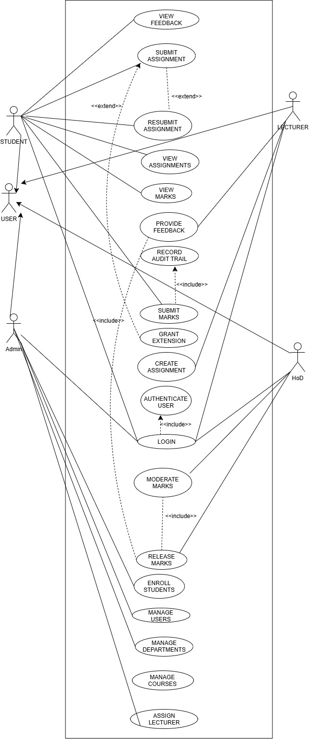
Generalization Relationship
- Student → User
- Lecturer → User
- HoD → User
- Administrator → User
Include Relationships
- Login → Authenticate User
- Submit marks → Provide Feedback
- Release Marks → Moderate Marks
Extend Relationships
- Resubmit Assignment → Submit Assignment
- Grant Extension → Submit Assignment

3.2 Fully Dressed Use Case Specification 1: Submit Assignment
Use Case ID
UC-01
Use Case Name
Submit Assignment
Primary Actor
Student
Goal
To submit an assignment for assessment.
Preconditions
- The student is logged into the system.
- The student is enrolled in the course.
- The assignment exists and is available for submission.
Main Flow
- The student selects a course.
- The system displays available assignments.
- The student selects an assignment.
- The student uploads the assignment file.
- The system validates the uploaded file.
- The system stores the submission.
- The system records the submission date and time.
- The system updates the submission status to Submitted.
- The system displays a submission confirmation message.
Alternative Flows
AF1: Student Has an Approved Extension
- The system detects an approved extension.
- The revised deadline is used instead of the original deadline.
- Submission proceeds normally.
AF2: Assignment Resubmission
- The student uploads a revised version before the deadline.
- The system replaces the previous submission with the latest version.
- The latest version becomes the version available for marking.
Exception Flows
EF1: Invalid File Format
- The uploaded file is not a supported format.
- The system displays an error message.
- The submission is rejected.
EF2: Submission More Than Three Days Late
- The system detects that the submission exceeds the allowable late period.
- The system records the submission.
- The submission is flagged to receive a mark of zero according to policy.
Post conditions
- The assignment submission is stored successfully.
- The submission is available for lecturer review.
- The submission status is updated accordingly.
Business Rules
- BR-03: Students may resubmit assignments only before the applicable deadline.
- BR-05: Late submissions incur a 10% penalty per day for up to three days.
- BR-06: Submissions more than three days late receive a mark of zero.

3.3 Fully Dressed Use Case Specification 2: Mark Submission
Use Case ID
UC-02
Use Case Name
Mark Submission
Primary Actor
Lecturer
Goal
To assess a student's assignment and provide feedback.
Preconditions
- The lecturer is logged into the system.
- The lecturer is assigned to the course.
- A student submission exists.
Main Flow
- The lecturer selects a course.
- The lecturer selects a student submission.
- The system displays the submitted assignment.
- The lecturer reviews the submission.
- The lecturer enters a mark.
- The lecturer enters written feedback.
- The system validates the mark.
- The system stores the mark and feedback.
- The submission status changes to Marked.
- The system records the action in the audit log.
Alternative Flows
AF1: Late Submission
- The system identifies that the submission was late.
- The system calculates the appropriate penalty.
- The adjusted mark is stored.
Exception Flows
EF1: Invalid Mark Entered
- The lecturer enters a mark greater than the assignment maximum.
- The system rejects the value.
- The lecturer enters a valid mark.
Post conditions
- Marks are saved successfully.
- Feedback is saved successfully.
- The submission is ready for moderation.
Business Rules
- BR-05: Late penalties must be applied.
- BR-06: Excessively late submissions receive zero.
- BR-07: All mark changes must be recorded in the audit log.

3.4 Fully Dressed Use Case Specification 3: Moderate and Release Marks
Use Case ID
UC-03
Use Case Name
Moderate and Release Marks
Primary Actor
Head of Department (HoD)
Goal
To verify marking quality and release approved results.
Preconditions
- The HoD is logged into the system.
- Student submissions have been marked.
- The course belongs to the HoD's department.
Main Flow
The HoD selects a course.
The system displays marked submissions.
The HoD reviews marks and feedback.
The HoD verifies compliance with assessment rules.
The HoD approves the marks.
The system updates the submission status to Moderated.
The HoD selects Release Marks.
The system makes marks and feedback available to students.
The system updates the status to Released.

Alternative Flows
AF1: Mark Adjustment Required
- The HoD identifies an inconsistency.
- The HoD modifies the mark.
- The HoD enters the reason for modification.
- The system records the modification in the audit log.
- Moderation continues.
Exception Flows
EF1: Missing Feedback
- The HoD identifies a submission without feedback.
- The system prevents mark release.
- The submission is returned to the lecturer for correction.
EF2: Unmarked Submission
- The HoD identifies an assessment that has not been marked.
- The system prevents moderation completion.
- The lecturer is notified to complete marking.
Post conditions
- Approved marks are released to students.
- Students can view marks and feedback.
- Moderation actions are recorded in the audit log.
Business Rules
- BR-04: Students may only view marks after release.
- BR-07: Mark modifications must be logged.
- BR-08: Only HoDs may release marks.

